SDC480 3.2 Assignment
ECPI university
Andy Kim
10/25/2025

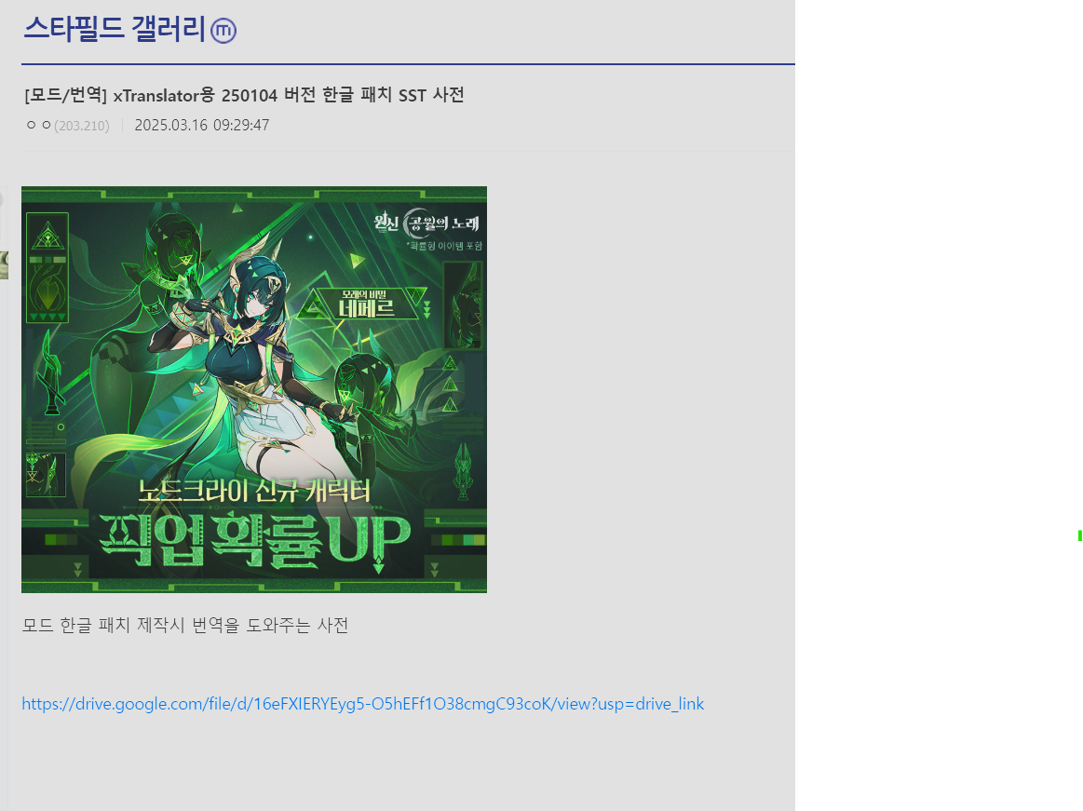
그림 1 Instead of manually clicking "API translation button" for every lines, I started looking for more efficient way and found there is actually dictionary file(SST) for Starfield main game in DC inside Starfield gallery (like subreddit of Starfield in Korea)
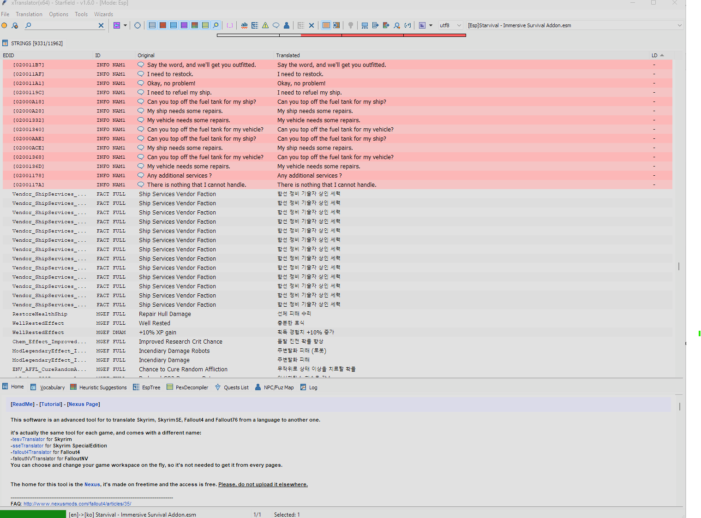
그림 2 I downloaded and click "import translation(SST)" in file menu of xTranslator and about 1/3 of job done because they are redundunt with Korean translation texts in Starfield main game Korean translation patch

- I learned again it is important to “work smart, not hard” it is someone in my previous job used to say.
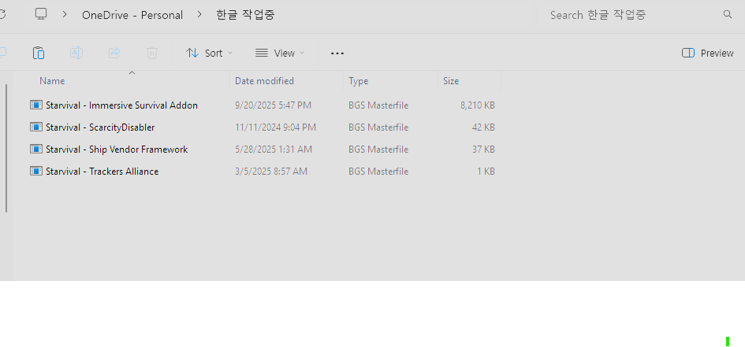
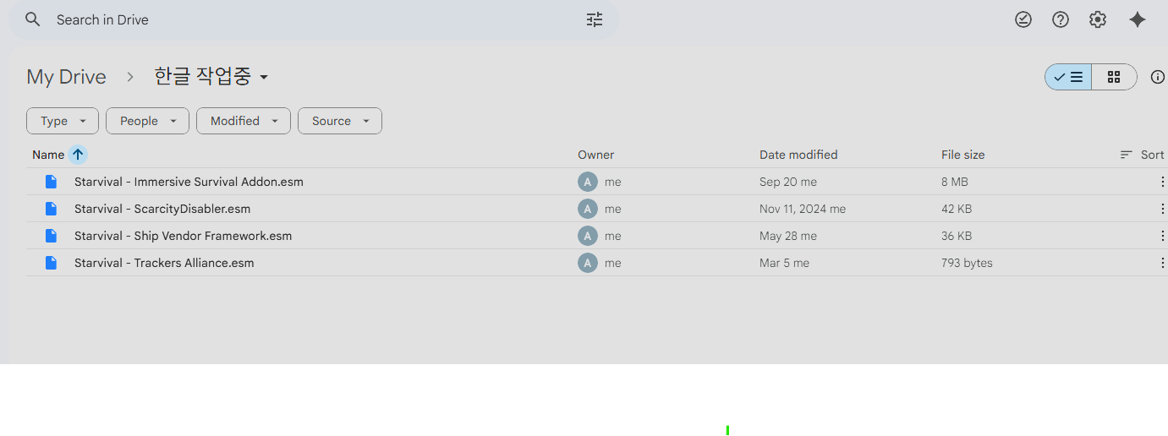
그림 3 Also backup files work in progress on google drive and one drive in any case

